**Project Report Format**

1. **INTRODUCTION**
   1. Project Overview
   2. Purpose
2. **LITERATURE SURVEY** 
   1. Existing problem
   2. References
   3. Problem Statement Definition
3. **IDEATION & PROPOSED SOLUTION** 
   1. Empathy Map Canvas
   2. Ideation & Brainstorming
   3. Proposed Solution
   4. Problem Solution fit
4. **REQUIREMENT ANALYSIS -** 
   1. Functional requirement
   2. Non-Functional requirements
5. **PROJECT DESIGN** 
   1. Data Flow Diagrams
   2. Solution & Technical Architecture
   3. User Stories
6. **PROJECT PLANNING & SCHEDULING S** 
   1. Sprint Planning & Estimation
   2. Sprint Delivery Schedule
   3. Reports from JIRA
7. **CODING & SOLUTIONING (Explain the features added in the project along with code)**
   1. Feature 1
   2. Feature 2
   3. Database Schema (if Applicable)
8. **TESTING** 
   1. Test Cases
   2. User Acceptance Testing
9. **RESULTS**
   1. Performance Metrics
10. **ADVANTAGES & DISADVANTAGES**
11. **CONCLUSION**
12. **FUTURE SCOPE**
13. **APPENDIX**
14. Source Code
15. GitHub & Project Demo Link
16. Project Report
17. Introduction
18. Abstract:
19. Sometimes elderly people forget to take their medicine at the correct time. They also forget which medicine they should take at that time. It is also difficult for doctors/caretakers to monitor the patients around the clock. To avoid this problem, a reminder system has been proposed. An app is built for the user (caretaker) which enables him to set the desired time and medicine. These details will be stored in the IBM Cloudant DB. If the medicine time arrives the web application will send the medicine name to the IoT (Internet of Things) Device through the IBM IoT platform. The device will receive the medicine name and notify the user with voice commands.
20. Keywords: *IoT, Web Application, Medicine Intake, IBM Cloudant.*
21. Literature Surveyya’

|  |  |  |  |  |  |
| --- | --- | --- | --- | --- | --- |
| 1. S.No. | 1. Link | 1. Publication | 1. Paper | 1. Author | 1. Inference |
|  |  |  |  |  |  |
|  |  |  |  |  |  |
|  |  |  |  |  |  |
|  |  |  |  |  |  |
|  |  |  |  |  |  |

1. References:
2. Santo, K., Chow, C. K., Thiagalingam, A., Rogers, K., Chalmers, J., & Redfern, J. (2017). MEDication reminder APPs to improve medication Adherence in Coronary Heart Disease (MedApp-CHD) Study: a randomised controlled trial protocol. BMJ open, 7(10), e017540.
3. Waykole, M., Prakash, V., & Nalini, N. H. S. (2016). Ardumed-smart medicine reminder for old people. Int J Sci Eng Res, 7, 650-654.
4. [3] Al-Mahmud, O., Khan, K., Roy, R., & Alamgir, F. M. (2020, June). Internet of things (IoT) based smart health care medical box for elderly people.
5. In 2020 International Conference for Emerging Technology (INCET) (pp. 1-6). IEEE.
6. Kader, M. A., Uddin, M. N., Arfi, A. M., Islam, N., & Anisuzzaman, M. (2018, October). Design & implementation of an automated reminder medicine box for old people and hospitals. In 2018 International conference on innovations in science, engineering, and technology (ICISET) (pp. 390-394). IEEE.
7. Yamamoto, Y., Huang, R., & Ma, J. (2010, November). Medicine management and medicine taking assistance system for supporting elderly care at home. In 2010 2nd International Symposium on Aware Computing (pp. 31-37). IEEE.
8. **DEFINING THE PROBLEM**
9. •Sometimes elderly people forget to take their medicine at the correct time.
10. •They also forget which medicine He / She should take at that particular time.
11. •And it is difficult for doctors/caretakers to monitor the patients around the clock. To avoid this problem, this medicine reminder system is developed.
12. •An app is built for the user (caretaker) which enables him to set the desired time and medicine.
13. These details will be stored in the IBM Cloud-ant DB.
14. •If the medicine time arrives the web application will send the medicine name to the IoT Device through the IBM IoT platform.
15. •The device will receive the medicine name and notify the user with voice commands.
16. 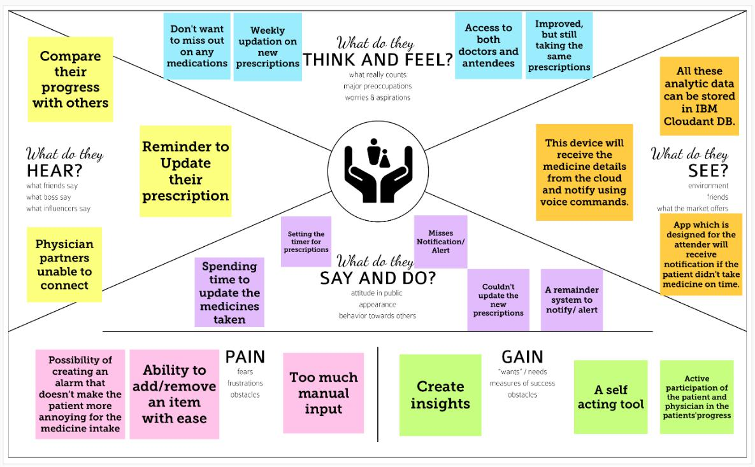
17. 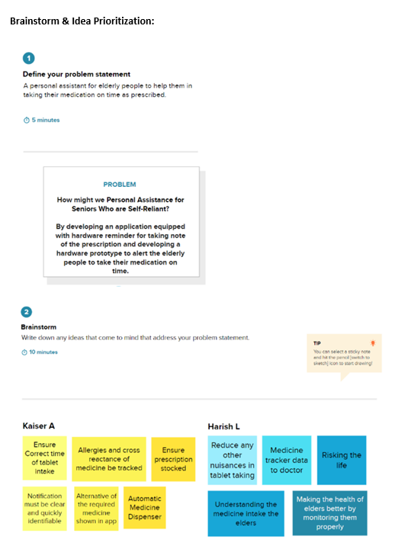
18. 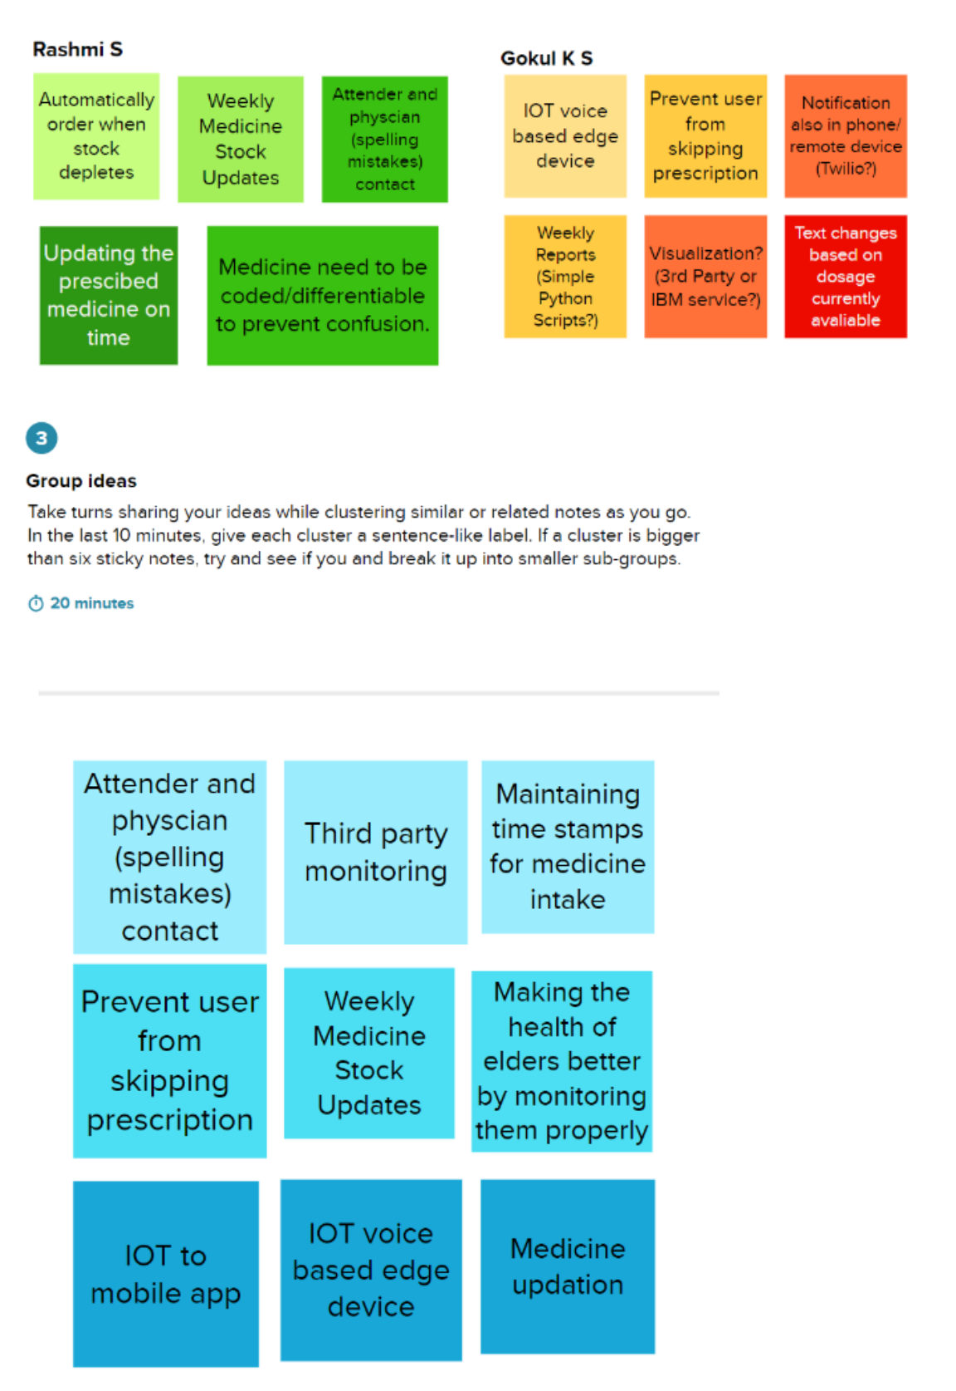
19. 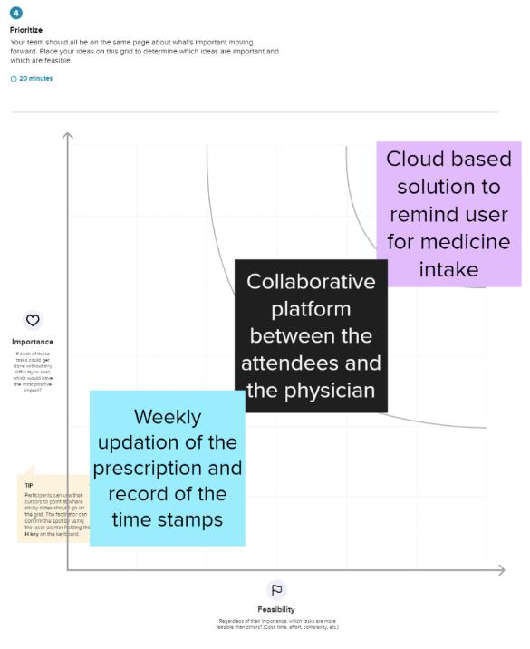

|  |  |  |  |  |
| --- | --- | --- | --- | --- |
| 1. **Proposed Solution:** | |  |  |  |
|  |  |  |  |  |
| 1. **S. No.** | 1. **Parameter** |  | 1. **Description** |  |
|  |  |  |  |  |
| 1. 1. | 1. Problem Statement (Problem to be |  | 1. Personal Assistance for Seniors Who Are Self- |  |
|  | 1. solved) |  | 1. Reliant |  |
|  |  |  |  |  |
| 1. 2. | 1. Idea / Solution description |  | 1. IoT – edge based real time cloud solution, that |  |
|  |  |  | 1. reminds the user to take the prescription on |  |
|  |  |  | 1. time. |  |
| 1. 3. | 1. Novelty / Uniqueness |  | 1. The prototype prevents the user from skipping |  |
|  |  |  | 1. them, by sending periodic reminders to both |  |
|  |  |  | 1. the attenders and the patients |  |
| 1. 4. | 1. Social Impact / Customer Satisfaction |  | 1. The client looks for a model that is feasible and |  |
|  |  |  | 1. easy to use. Since the one's we are targeting |  |
|  |  |  | 1. are the elderly, it should be a model that |  |
|  |  |  | 1. enables them to handle the model on their |  |
|  |  |  | 1. own. |  |
| 1. 5. | 1. Business Model (Revenue Model) |  | 1. The business impact of this project lies on the |  |
|  |  |  | 1. hands of target audiences including elderly and |  |
|  |  |  | 1. physicians. |  |
| 1. 6. | 1. Scalability of the Solution |  | 1. The project we are proposing is based on cloud, |  |
|  |  |  | 1. so the idea to expand the prototype to a next |  |
|  |  |  | 1. level will not involve more man power since |  |
|  |  |  | 1. everything happens via cloud. |  |

1. **Problem – Solution Fit:**
2. Here our problem is elderly people forget to take their medicine at the correct time and they forget which medicine to take on that time. It is difficult for the caretakers or doctors to oversee them always on that right time every day.
3. **Purpose:**
4. An app is built for the user (caretaker) which enables him to set the desired time and medicine. These details will be stored in the IBM Cloudant DB.
5. If the medicine time arrives the web application will send the medicine name to the IoT Device through the IBM IoT platform.
6. The device will receive the medicine name and notify the user with voice commands.
7. **Template:**

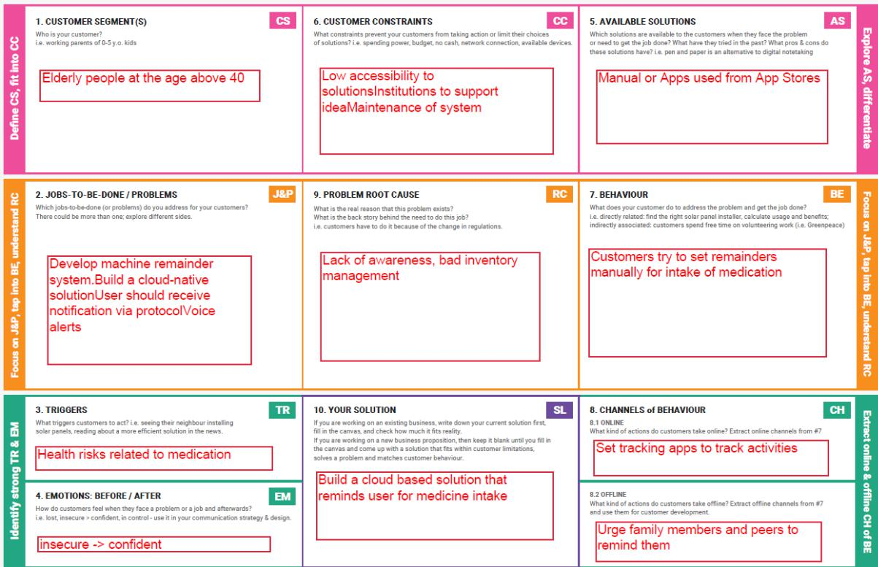

1. **Data Flow Diagrams:**
2. A Data Flow Diagram (DFD) is a traditional visual representation of the information flows within a system. A neat and clear DFD can depict the right amount of the system requirement graphically. It shows how data enters and leaves the system, what changes the information, and where data is stored.

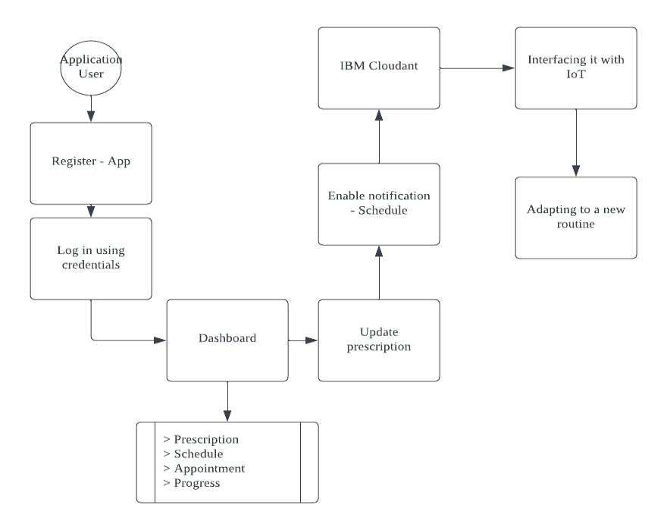

1. 
2. **Functional Requirements:**
3. Following are the functional requirements of the proposed solution.

|  |  |  |
| --- | --- | --- |
| 1. **FR No.** | 1. **Functional Requirement (Epic)** | 1. **Sub Requirement (Story / Sub-Task)** |
|  |  |  |
| 1. FR-1 | 1. **User Registration** | 1. Registration through Form |
|  |  | 1. Registration through Gmail |
| 1. FR-2 | 1. **User Confirmation** | 1. Confirmation via Email |
|  |  | 1. Confirmation via OTP |
| 1. FR-3 | 1. **Log in** | 1. Username and Password - credentials |
|  |  |  |
| 1. FR-4 | 1. **Forget Password** | 1. Link to reset |
|  |  | 1. OTP via mail |
| 1. FR-5 | 1. **Navigation** | 1. Simple and easy navigation |
|  |  | 1. Limited gesture |
| 1. FR-5 | 1. **Cloud Services** | 1. Easy access of database |
|  |  |  |

1. **Non-functional Requirements:**
2. Following are the non-functional requirements of the proposed solution.

|  |  |  |
| --- | --- | --- |
| 1. **FR No.** | 1. **Non-Functional Requirement** | 1. **Description** |
|  |  |  |
| 1. NFR-1 | 1. **Usability** | 1. Login within 2 seconds when the data is fed |
|  |  | 1. Convenient to be used by anyone(elderly) |
| 1. NFR-2 | 1. **Security** | 1. Two step Verification, Biometric (facial recognition |
|  |  | 1. and finger print) |
| 1. NFR-3 | 1. **Reliability** | 1. Cloud based device |
|  |  |  |
| 1. NFR-4 | 1. **Performance** | 1. Quick to respond |
|  |  |  |
| 1. NFR-5 | 1. **Availability** | 1. Available for screens with different dimensional |
|  |  | 1. ratio (monitors, tablets, mobile phones) |
| 1. NFR-6 | 1. **Scalability** | 1. Database accessed through cloud |
|  |  |  |

1. **Customer Journey Map:**
2. 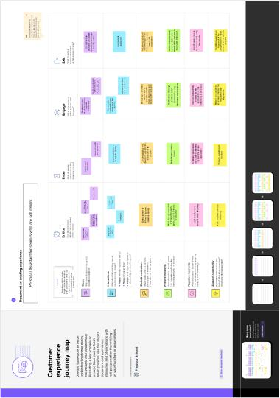
3. **Solution Architecture:**
4. Solution architecture is a complex process – with many sub-processes – that bridges the gap between business problems and technology solutions. Its goals are to:
5. Attenders and physicians to set remainders in accordance with the prescriptions
6. Database to track the activities and timestamps
7. Node-Red acts as an interface between the database and the UI
8. Build a cloud native solution
9. **Solution Architecture Diagr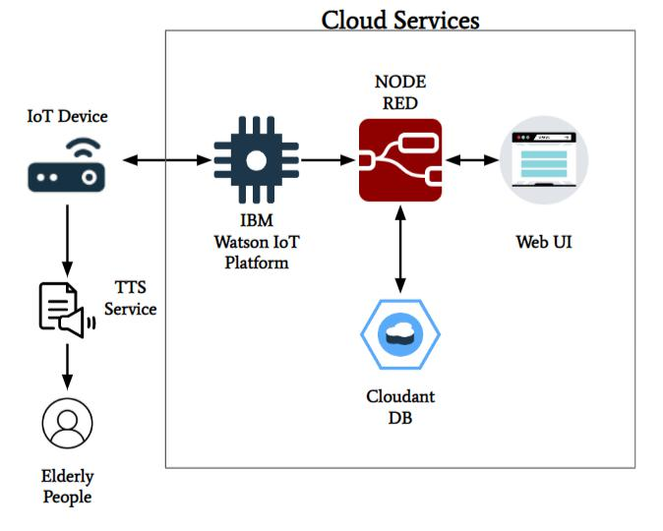am:**
10. **Technical Architecture:**

